Project Report Format

1. INTRODUCTION
   1. Project Overview

**Visualizing Housing Market Trends — An Analysis of Sale Prices and Features Using Tableau**

**Objective:**

The primary goal of this project is to explore, analyze, and visualize housing market trends using interactive Tableau dashboards. By analyzing the relationship between home features and sale prices, we aim to uncover patterns and insights that can guide home buyers, sellers, and real estate professionals.

**Conclusion:**

This project successfully demonstrates how Tableau can transform raw housing data into **insightful, visual storytelling** tools. It helps stakeholders make data-driven decisions in the real estate market and can be extended further with predictive analysis or live market feeds.

* 1. Purpose

The purpose of this project is to **analyze and visualize housing market data** to uncover meaningful insights about the relationship between property features and sale prices. Using Tableau, this project aims to present interactive visual dashboards that make it easier for users to:

* **Understand key trends** in the housing market, such as how home renovations, location, and property features (like bedrooms, bathrooms, and floors) affect prices.
* **Identify patterns** in house sales across years and regions to support data-driven decisions.
* **Explore complex datasets visually**, allowing real estate professionals, buyers, and sellers to interpret housing data without needing technical knowledge.

1. IDEATION PHASE
   1. Problem Statement

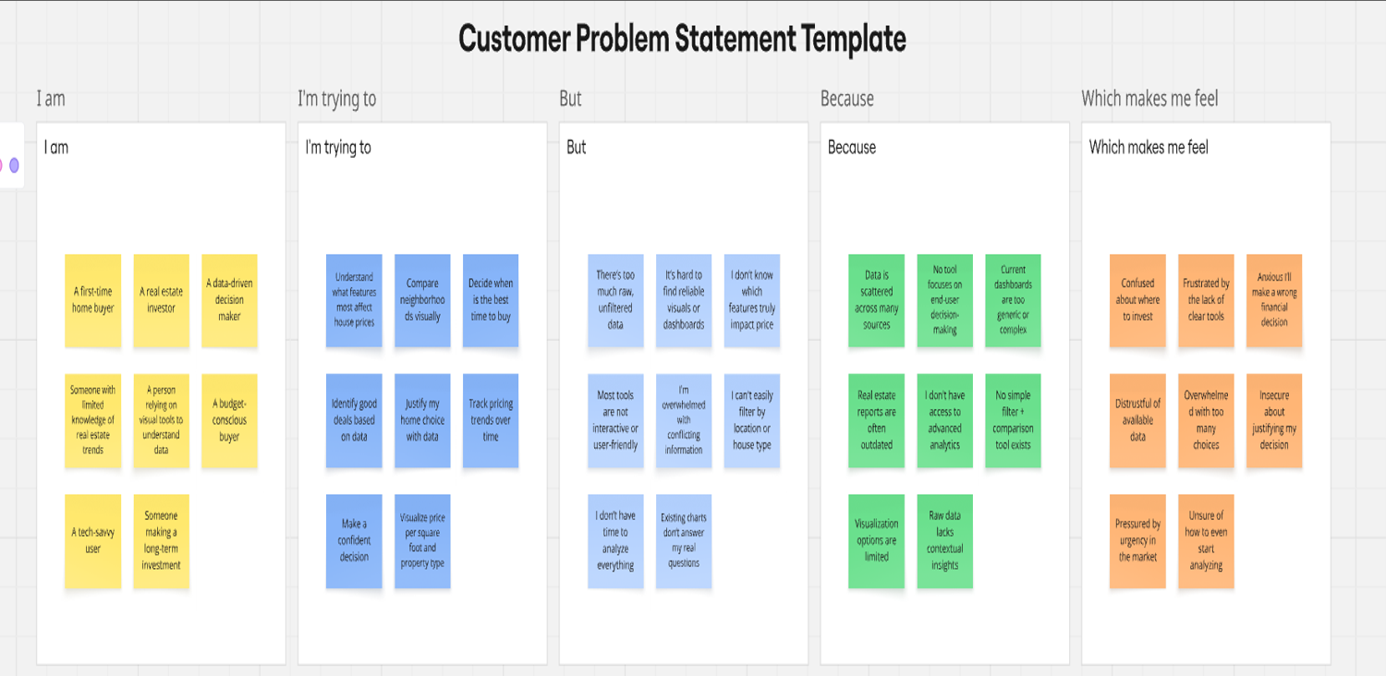

2.2 Empathy Map Canvas

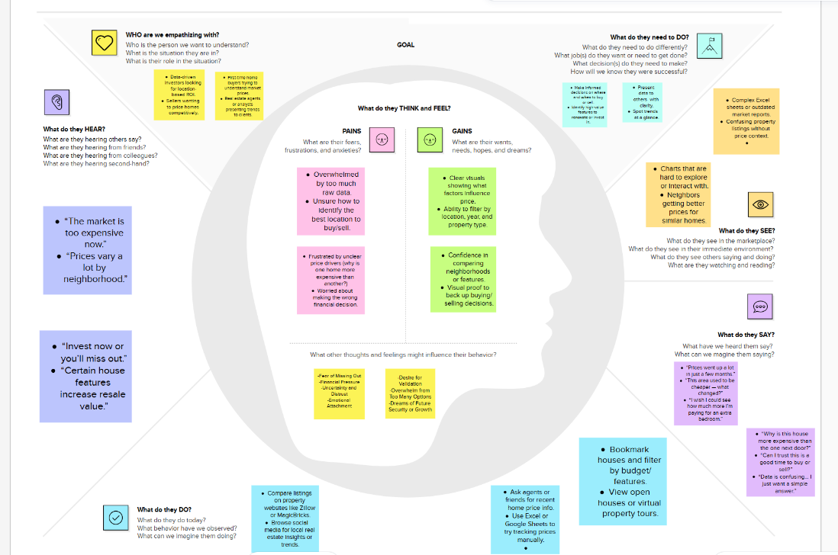

2.3 Brainstorming

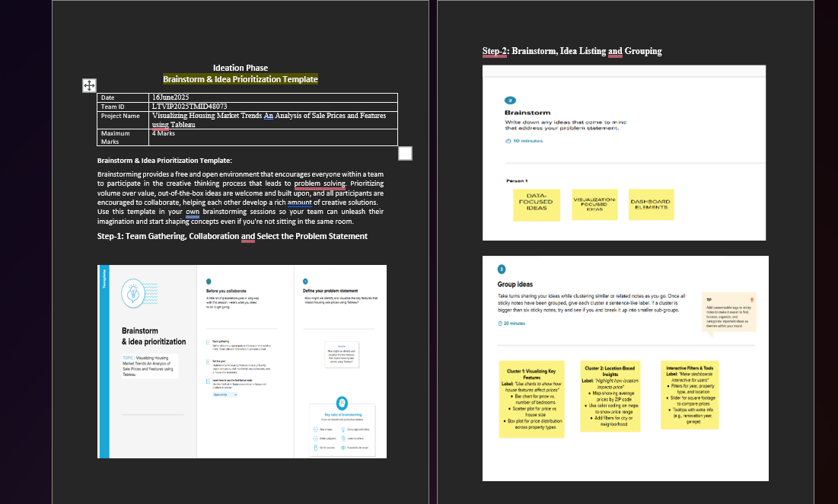

3.REQUIREMENT ANALYSIS

a.Customer Journey Map: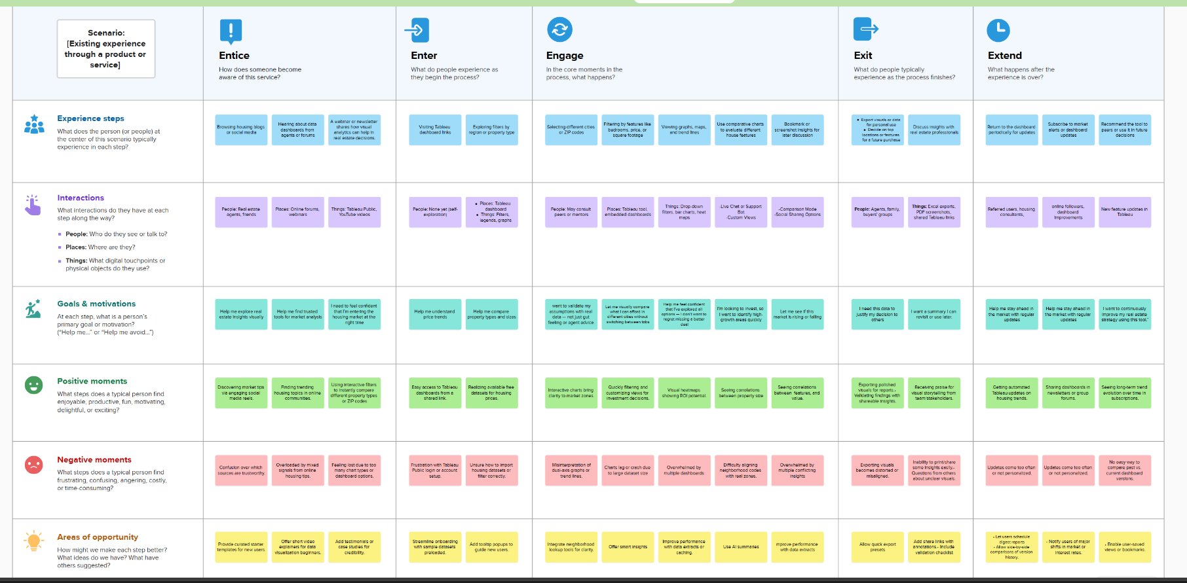

b.Data Flow Diagram

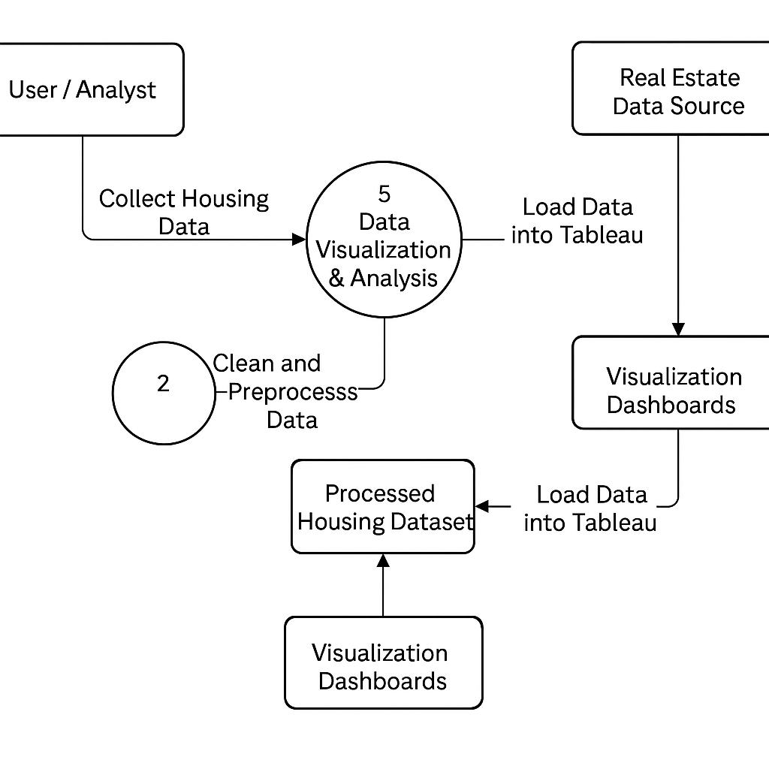

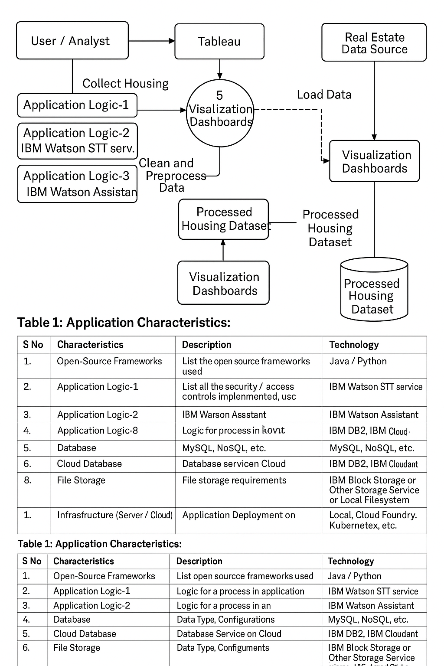C.Technology Stack :

D.Solution Requirement :

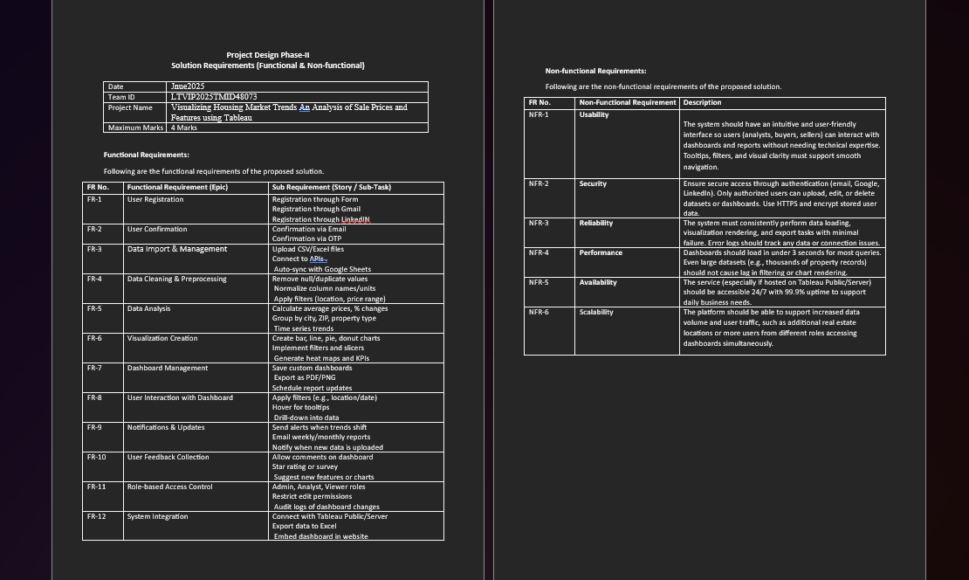there are some **Functional Requirements and non-Functional Requirements that have been in detail in the phases**

1. PROJECT DESIGN :

4.1 Problem Solution Fit :

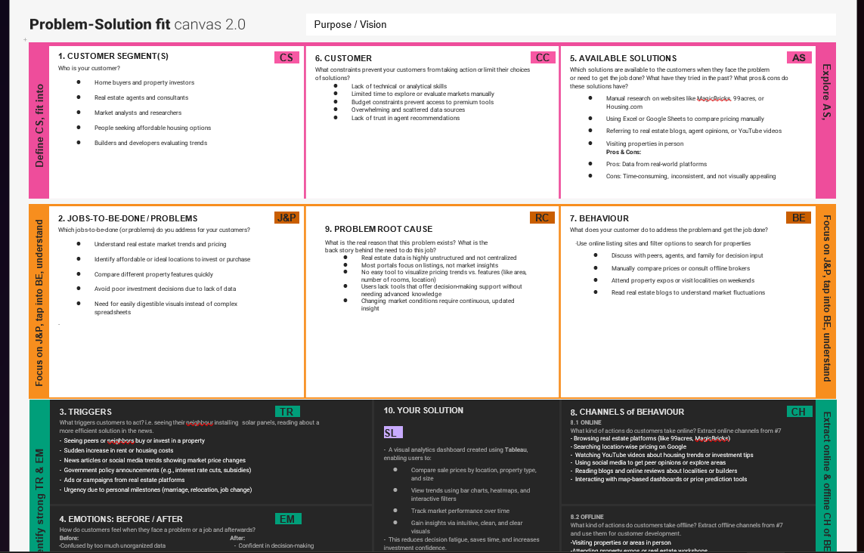

4.2 Proposed Solution :

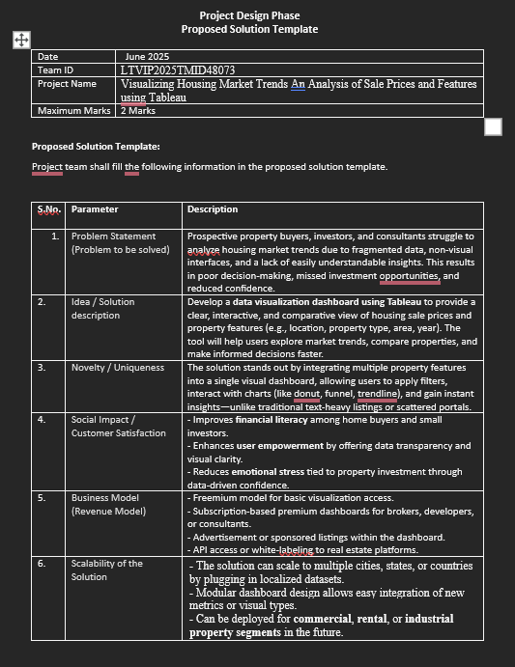

4.3 Solution Architecture :

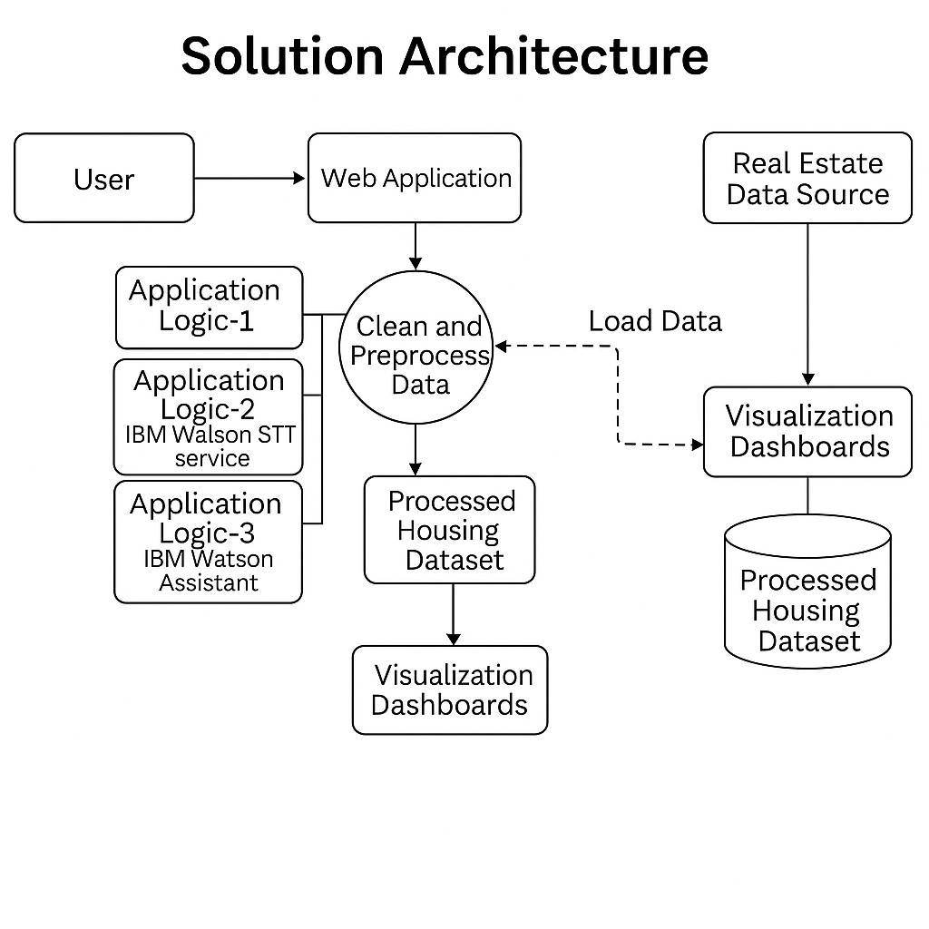5. PROJECT PLANNING & SCHEDULING

5.1 Project Planning :

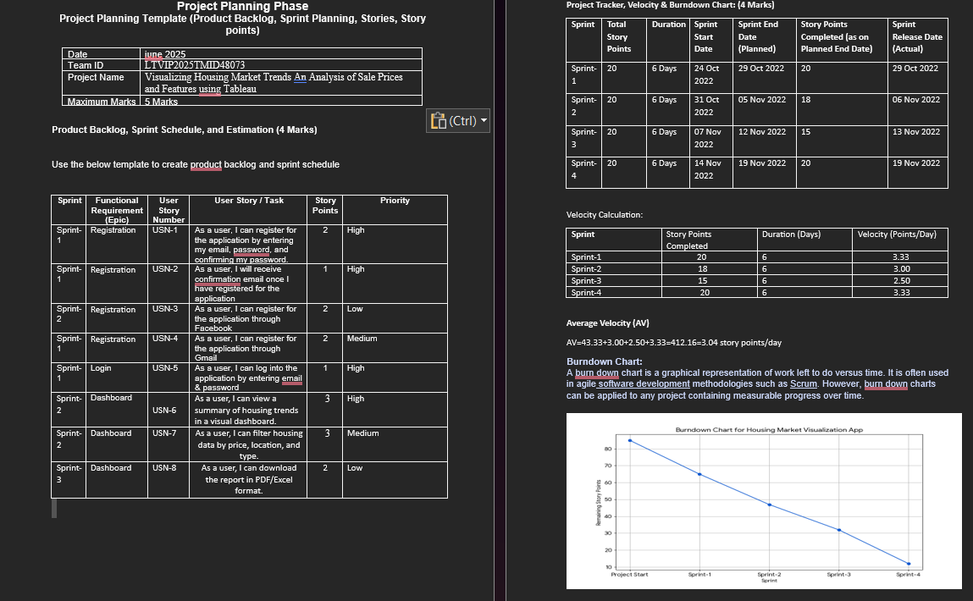

6. FUNCTIONAL AND PERFORMANCE TESTING

6.1 Performance Testing :

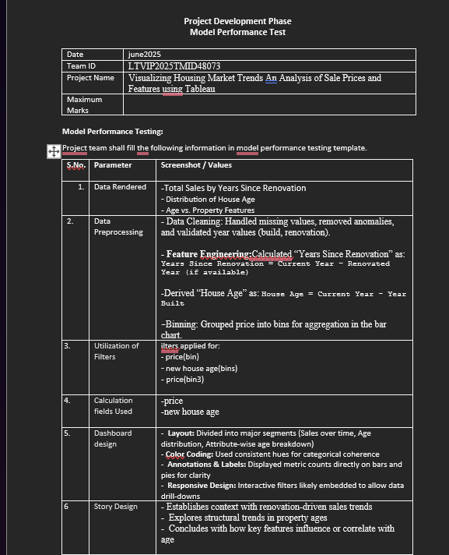

RESULTS

7.1 Output Screenshots :

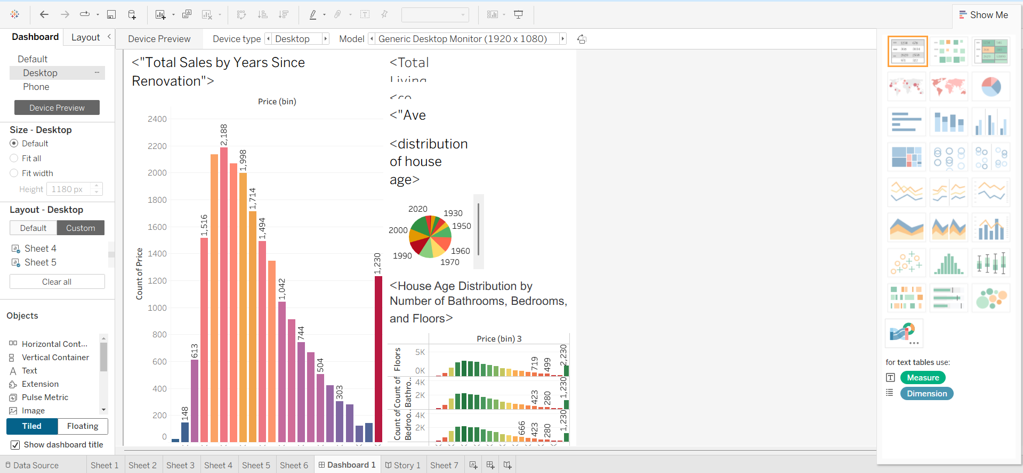

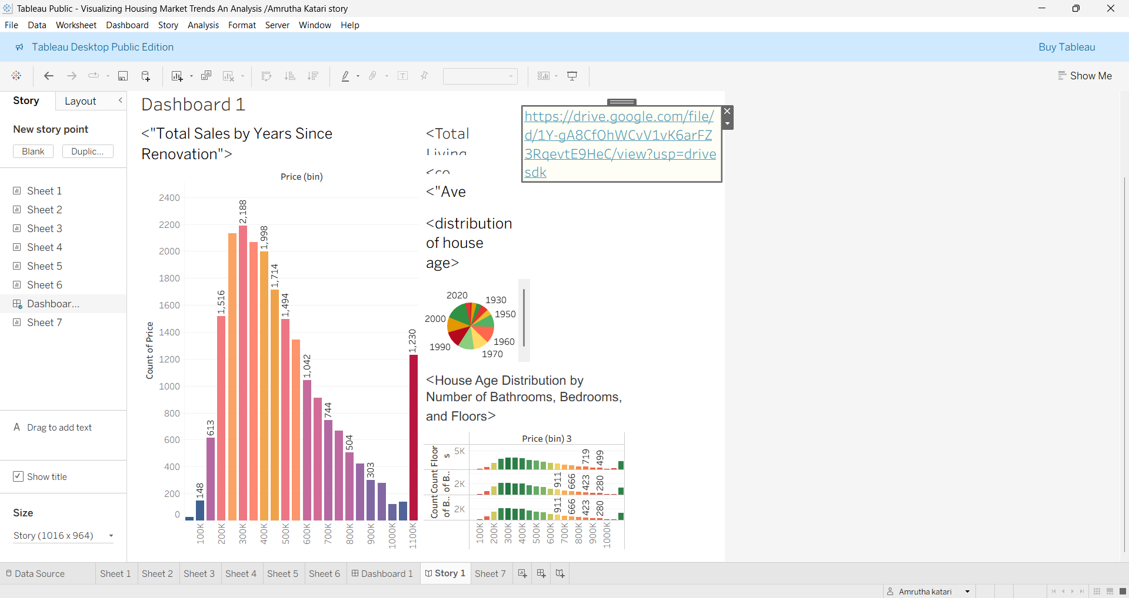

|  |  |  |
| --- | --- | --- |
|  |  |  |
|  |  |  |

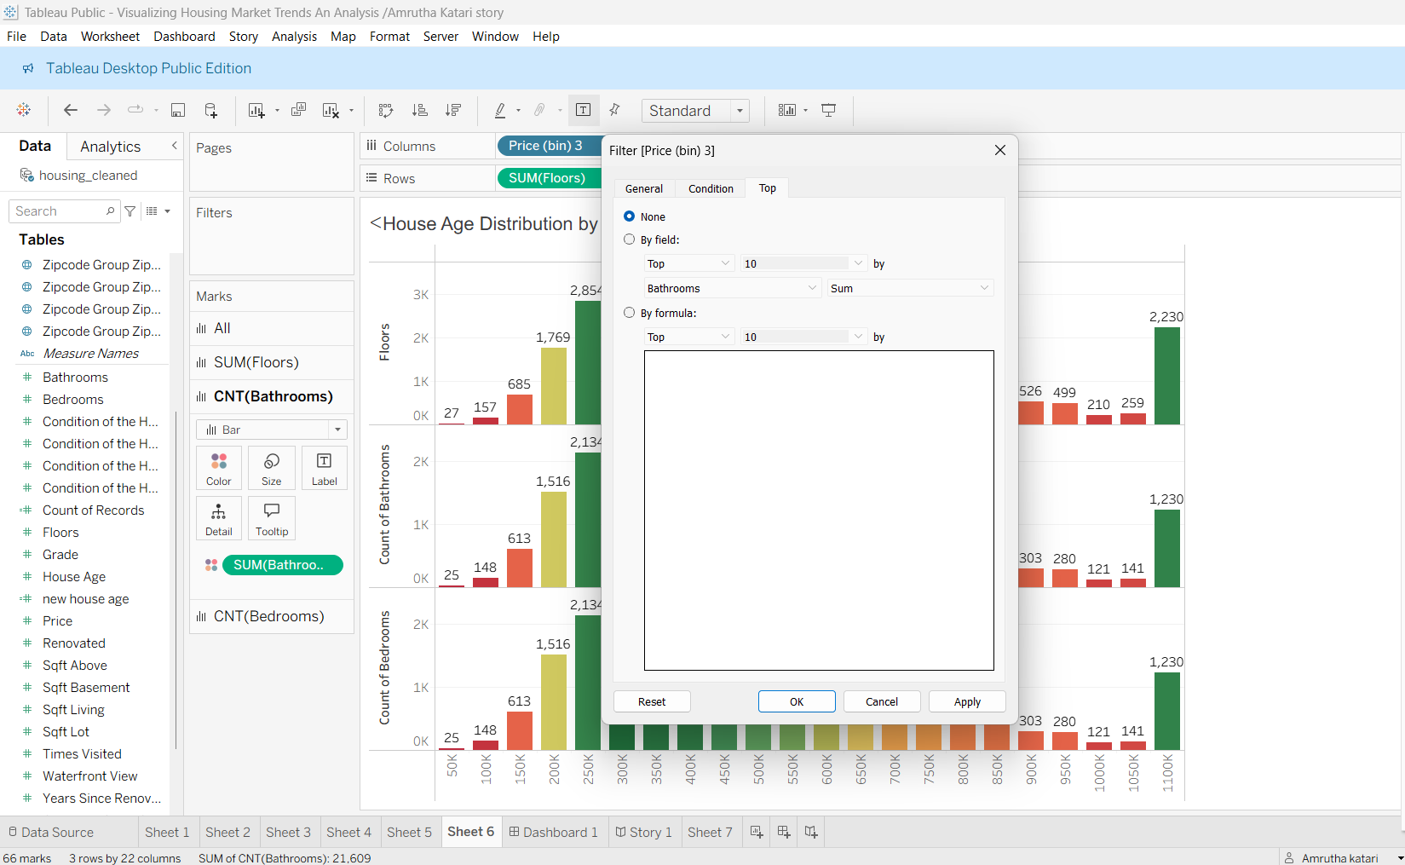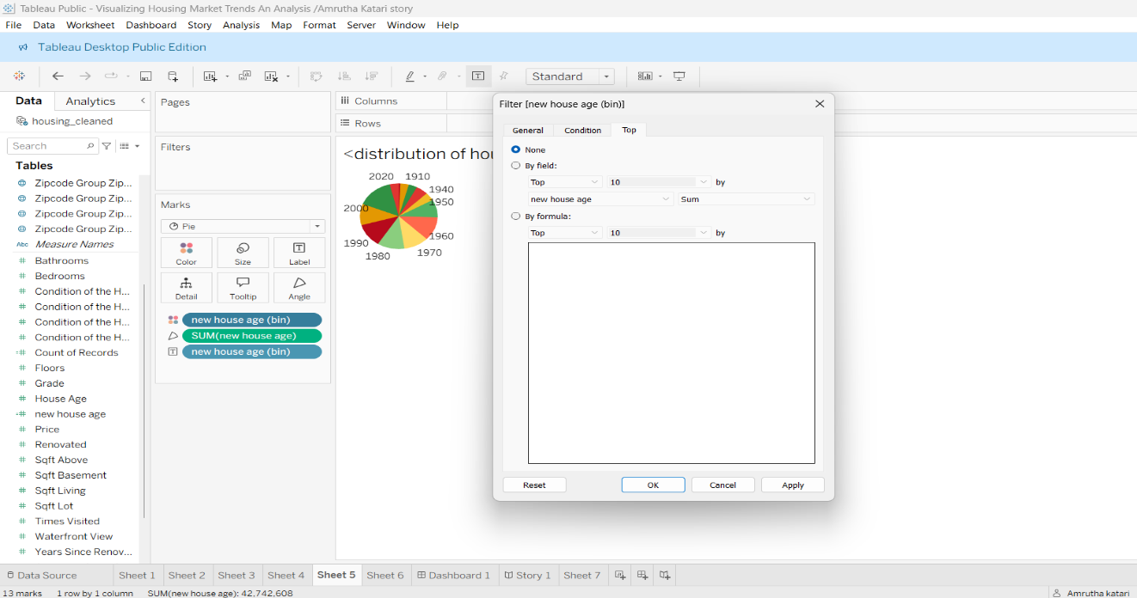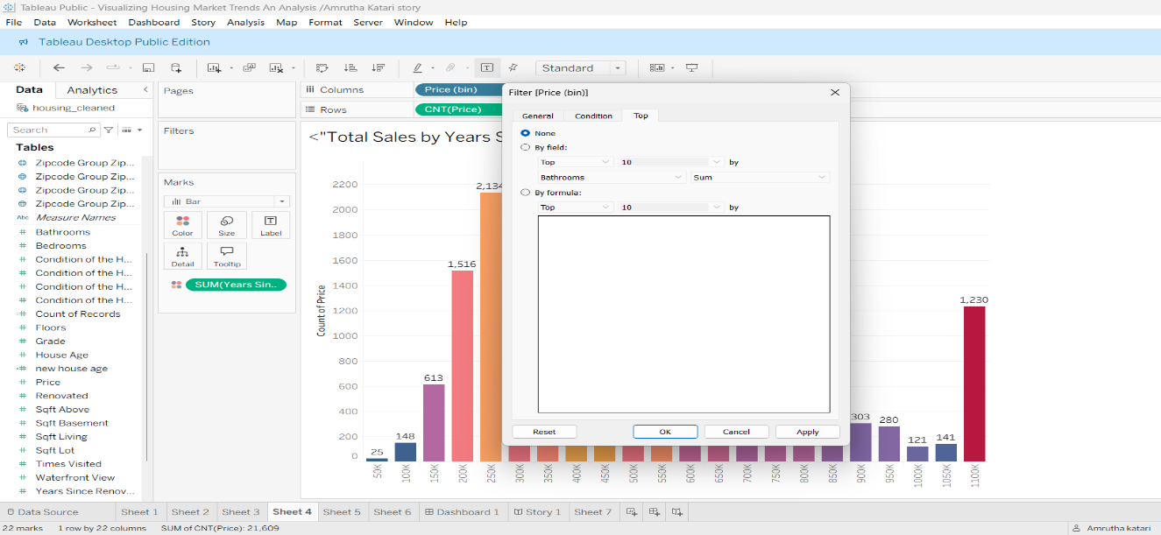

**8.Advantages & DISADVANTAGES**

**Advantages**

* **Visual Insights at a Glance** Easily interpret housing market behavior using graphs and dashboards.
* **Dynamic Filtering and Interaction** Filters empower users to explore data dimensions like property age, renovation status, and features with flexibility.
* **Fast Decision Support** Stakeholders can identify price trends, age distribution, and renovation effects without diving into raw data.
* **Calculation Fields for Deeper Analysis** Custom formulas reveal relationships between renovation, price, and structure—powerful for data storytelling.
* **Improved Data Presentation** Pie charts, clustered bars, and binned histograms simplify interpretation of complex multi-variate relationships.

**Disadvantages**

* **Limited Scope of Raw Data Insights are only as good as the data—missing location, neighborhood, or economic context could limit conclusions.**
* **Manual Preprocessing Effort Data cleaning, feature engineering, and creating bins require upfront effort before visualization is meaningful.**
* **Platform Dependency Users must have Tableau or appropriate viewers to explore interactive elements fully.**
* **Scalability Constraints with Larger Datasets Tableau Public (free version) has row limits, and performance may lag on very large datasets.**

9. CONCLUSION

This project effectively leveraged Tableau to turn raw housing data into clear, actionable insights. Through structured preprocessing, calculated fields, and interactive dashboards, it revealed key trends in property age, renovation impact, and feature distribution. The result is a scalable, intuitive tool that empowers data-driven decisions in real estate analysis.

10. FUTURE SCOPE

Add location maps, predictive models, real-time data updates, mobile views, and advanced analytics for a more powerful, scalable solution.

11. APPENDIX

Dataset Link :